

12 PHYSICS

MOMENTS & EQUILIBRIUM
MOMENT (TORQUE)

A moment (M) or torque (τ) is a measure of the turning effect of a force about a point.

It is always applied to a rigid structure pivoting about a given point.
i.e. It doesn’t apply to ropes or wires which aren’t rigid.

The magnitude of a moment is given by:

where M = the moment or torque (Nm)
F = the force causing the turning effect (N)
r = the perpendicular distance from the point of rotation to the line
of action of the force (m)

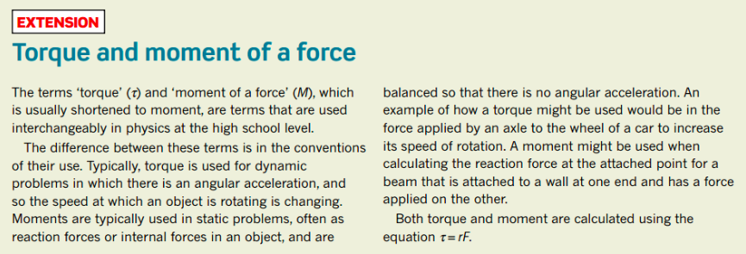

Examples

1. Calculate the moment exerted in the following.

There are two ways to solve the above problem.

(i) Find r - perpendicular distance to the line of action of the force.
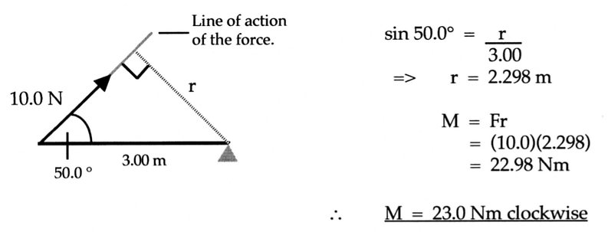
(ii) Find the perpendicular component of the force (preferred method).

2.
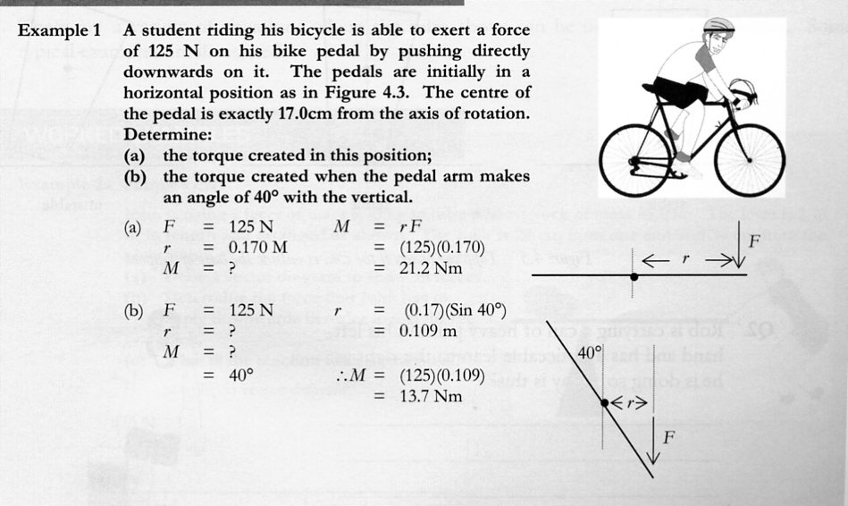

EQUILIBRIUM

Definitions

TRANSLATIONAL MOTION: movement in a straight line.

ROTATIONAL MOTION: spins about an axis or fixed point.

A body can possess one or both of these motions.

If a body moves with constant velocity or is at rest, it is not accelerating.
i.e. Σ F = 0
∴ It is in mechanical equilibrium.

If a rigid body does not rotate about a given point, then all of the moments acting on it must balance.
i.e Σ M = 0
∴ It is in rotational equilibrium.

For a rigid body to be in equilibrium, it must be in mechanical equilibrium and rotational
equilibrium.

Conditions Of Equilibrium

1. The resultant of all forces acting on a body must be zero.
i.e Σ F =0

=> Σ F_{v} = 0 Σ F_{h} = 0

2. If a body has a number of coplanar forces acting on it, then the algebraic sum of their
moments about any point in the plane is zero.
i.e. Σ M = 0

This second condition for equilibrium is known as the Principle of Moments.

It can be written as:

Examples

1. See-Saws
A uniform beam 5.00 m long has a mass of 0.200 kg hung at one end and a mass of 0.500 kg
hung at the other end. When the beam is pivoted at a point 1.50 m from the larger mass, the
beam just balances. Calculate:

(a) the weight of the beam.
(b) the reaction force exerted by the fulcrum at the pivot point.

2. Ropes And Cables

(No rigid body is present so moments are not considered.)

Two cranes are used to lift a sea-container from the hold of a ship as shown. The container
weighs 1.15 x 10⁴ N and moves at constant velocity vertically. Calculate the tension in each
cable.

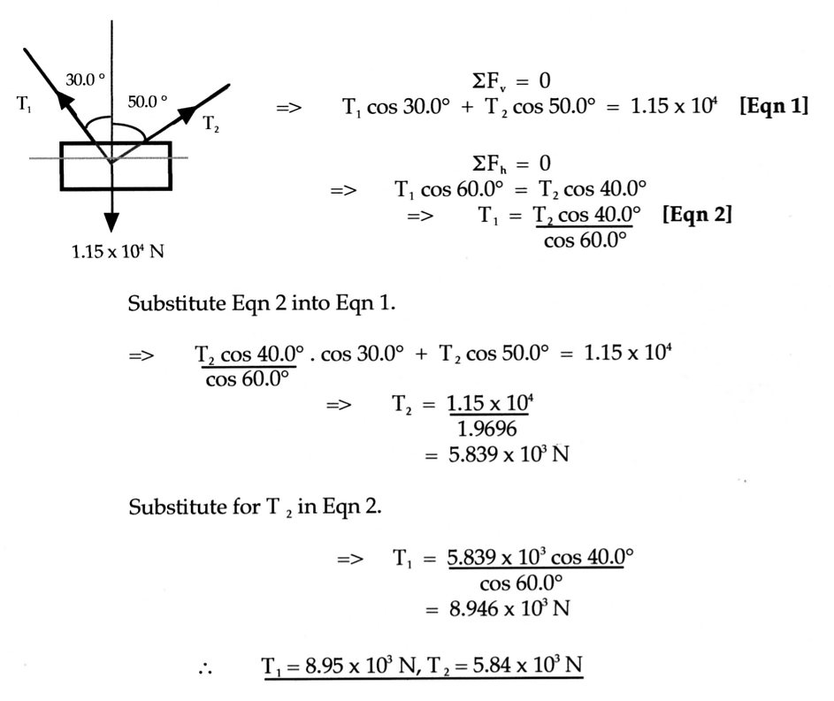

Note

This problem can be solved by having the three vectors acting form a “null-vector triangle”. That is, the vectors add head-to-tail to give a complete triangle.

This is possible since ΣF = 0.

The following example shows both methods.

Choose the method that you find easiest to understand and use!

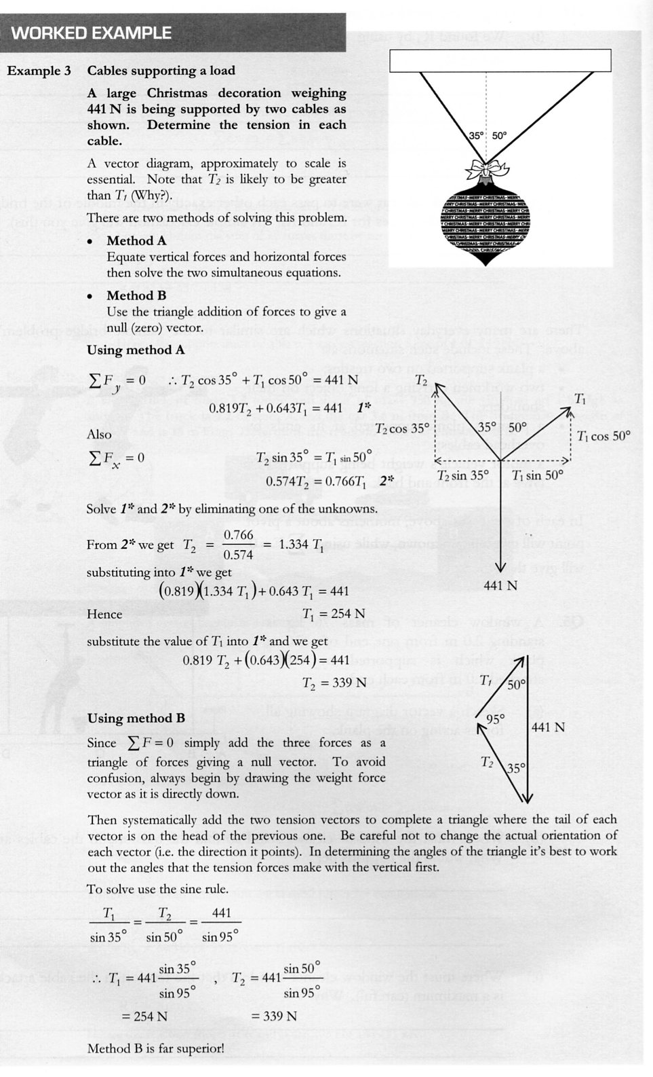
3. Signs/Drawbridges
A sign weighing 1.50 x 10² N is hung at the end of a 4.00 m long uniform steel bar weighing
40.0 N. The bar is held horizontal by a wire attached 1.00 m from the sign and forming an angle of 55.0° to the wall. Calculate:

(a) the tension in the wire.
(b) the reaction force at the pivot of the wall onto the bar.

Spare page
4. Ladder Against A Wall
One end of a uniform ladder 6.00 m long and weighing 4.00 x 10² N rests against a smooth
wall, forming an angle of 20.0° to it. A person weighing 6.50 x 10² N is standing on a rung
2.00 m from the bottom of the ladder. Calculate:

(a) the force exerted by the wall onto the ladder.
(b) the reaction force exerted by the ground onto the base of the ladder.

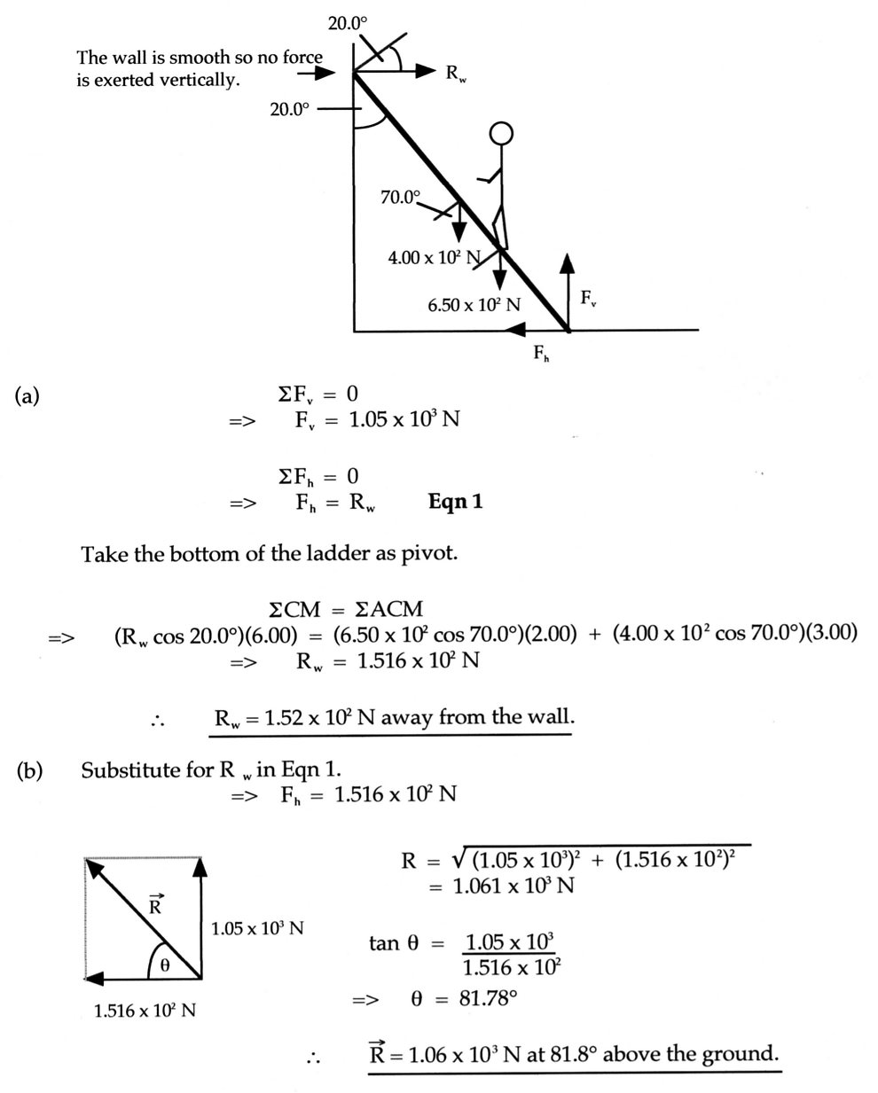

Spare Page
5. Bridges
A rigid uniform plank 5.00 m long and weighing 2.00 x 10² N is supported by two trestles -
one at end A and the other 1.00 m in from end B. If a man weighing 8.00 x10² N stands
2.00 m away from end B, calculate the force exerted by each trestle on the plank.

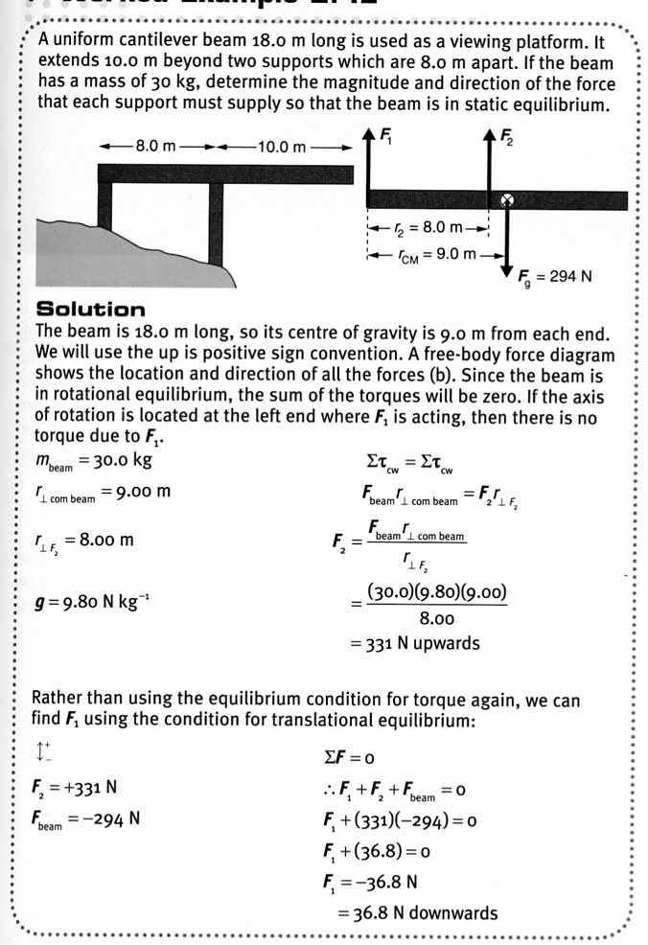

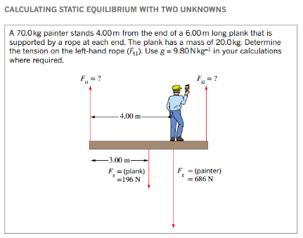
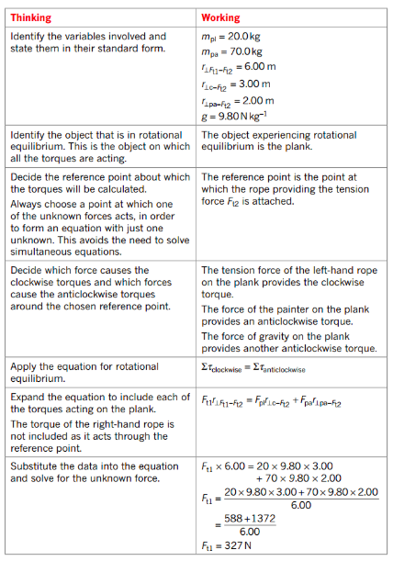
6. Free-Standing Step Ladder

These types of problems can be very difficult and won't be considered for the WACE examination.

A man weighing 8.00 x 10² N stands on top of a step ladder weighing 2.00 x 10² N as shown.
The rope is attached 0.700 m from the bottom of the ladder. Calculate:

(a) the reaction force exerted by the ground (assumed to be smooth).
(b) the tension in the rope holding the sides of the ladder together.

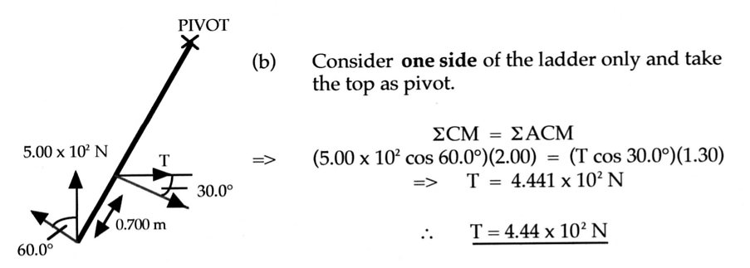
7. Lamina

These types of problems can be very difficult and won't be considered for the WACE
examination.

For the following lamina, determine the position of the centre of mass from point D.

Types Of Equilibrium

Objects are stable if their centre of mass falls inside their base of support.

They will return to their original position after a small displacement.

e.g.

If the block is tipped too far, there is no restoring moment and the block falls over. This is
unstable equilibrium.

Any object that is suspended will have stable equilibrium since its centre of mass will fall directly below the point of support.

e.g.

There is a third possible type of equilibrium - neutral equilibrium.

This occurs for objects whose centre of mass does not rise nor fall when the object is displaced
(E_{p} remains constant).

e.g.

The table below summarises the characteristics of the three types of equilibrium.

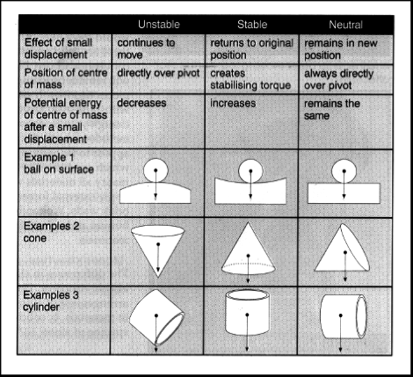

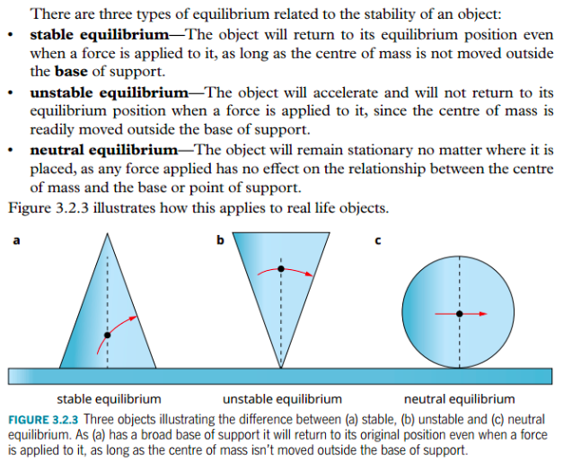

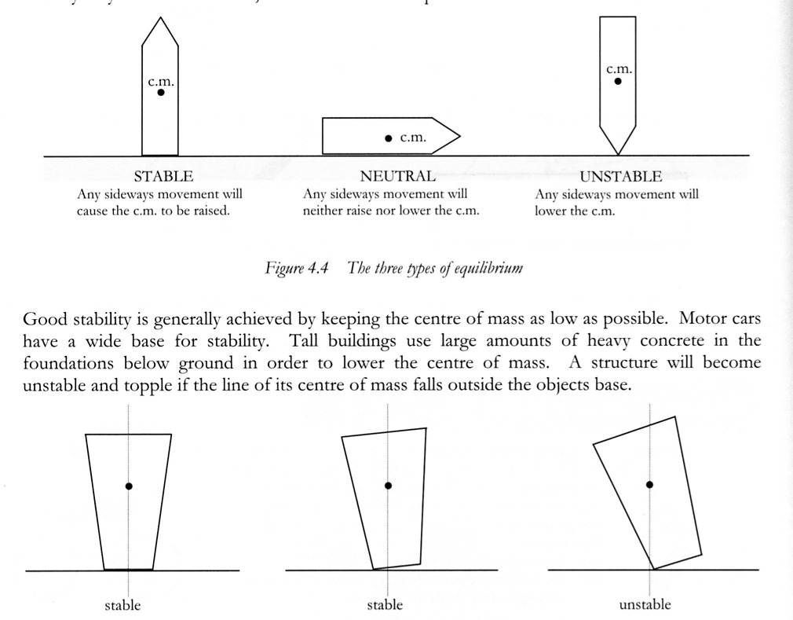

Example

